**AWS Lambda**

**Here you will learn how to create a lambda function in AWS**

1. Open AWS console and click on lambda function service.

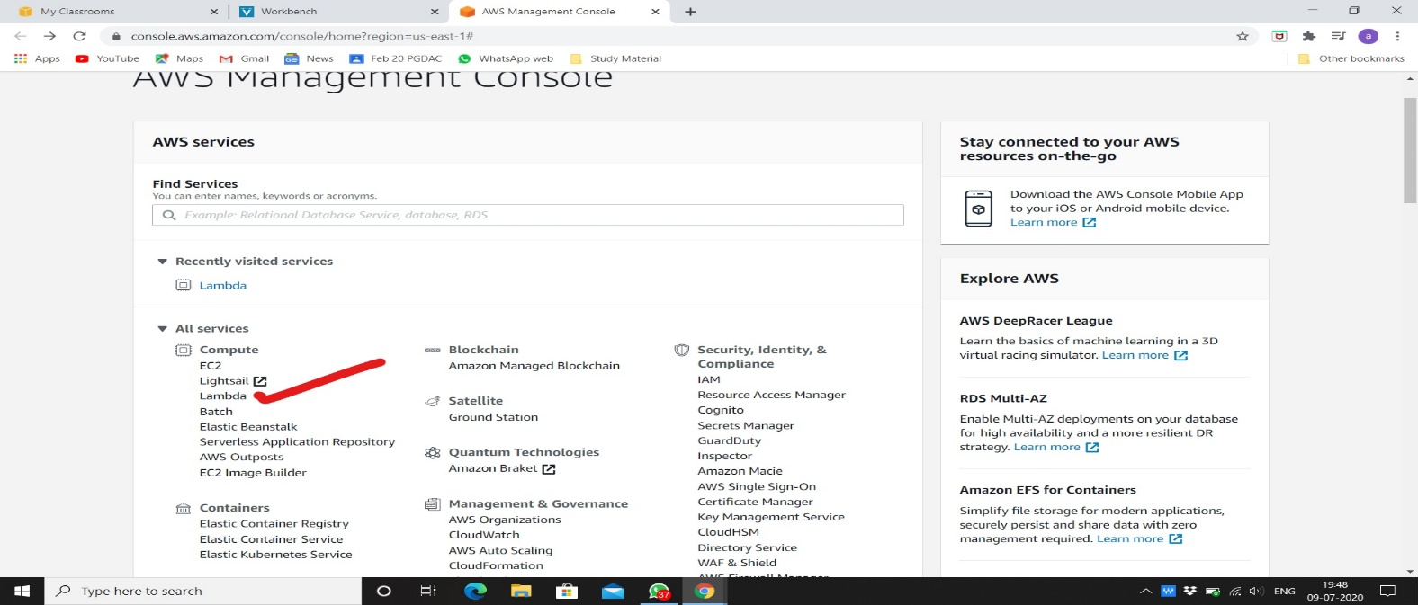

1. Click on create function.

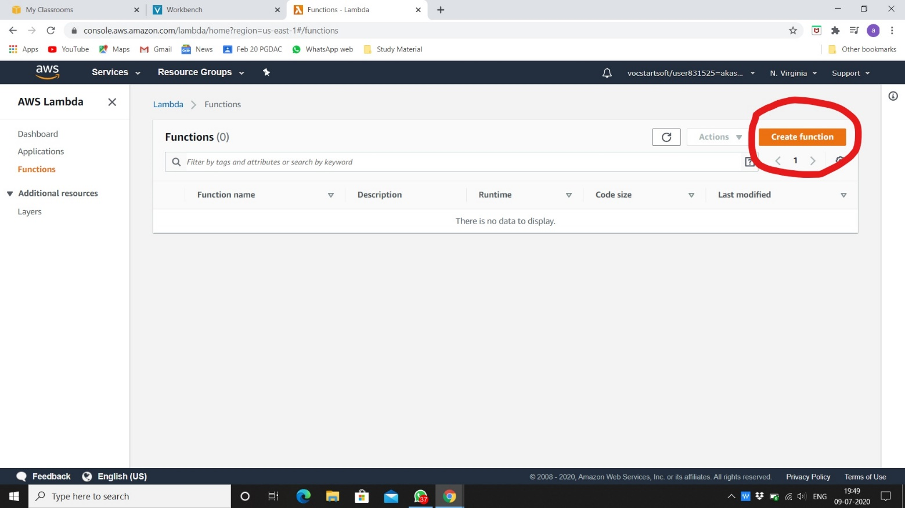

1. Use blueprint for using existing function.

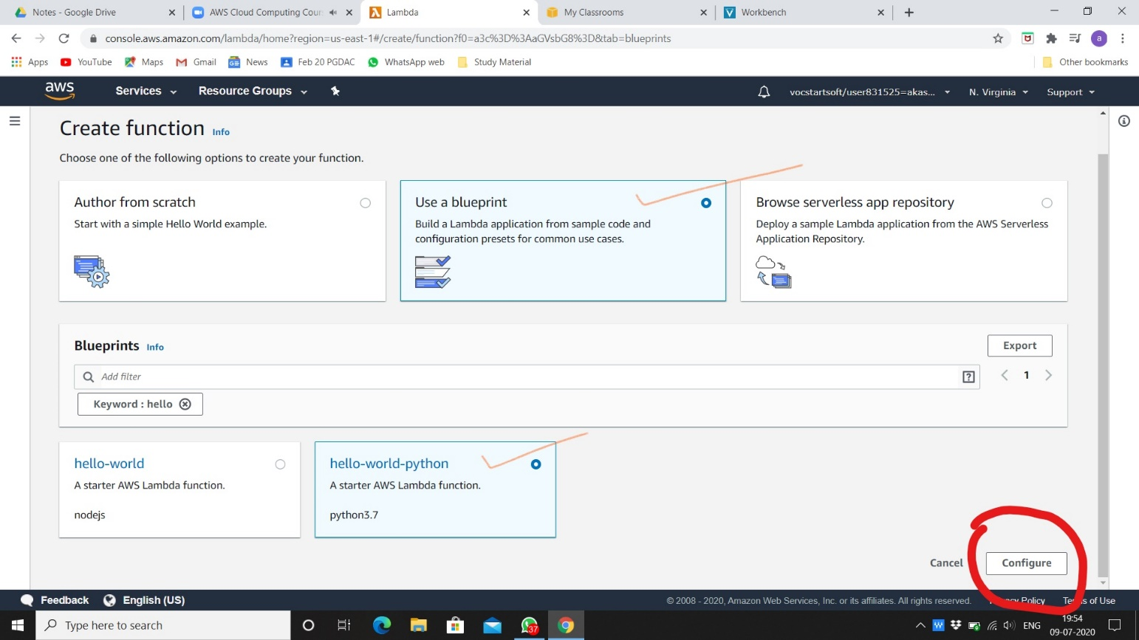

1. Give name to the lambda function and use existing role robomaker_students.

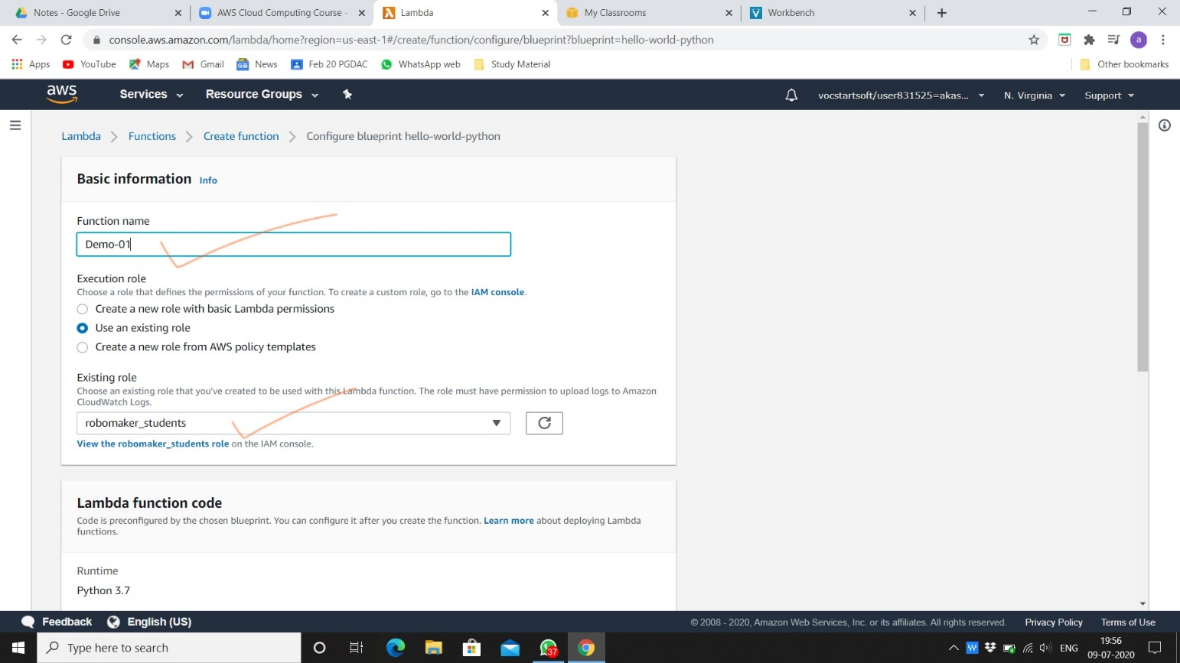

1. Click on create function.

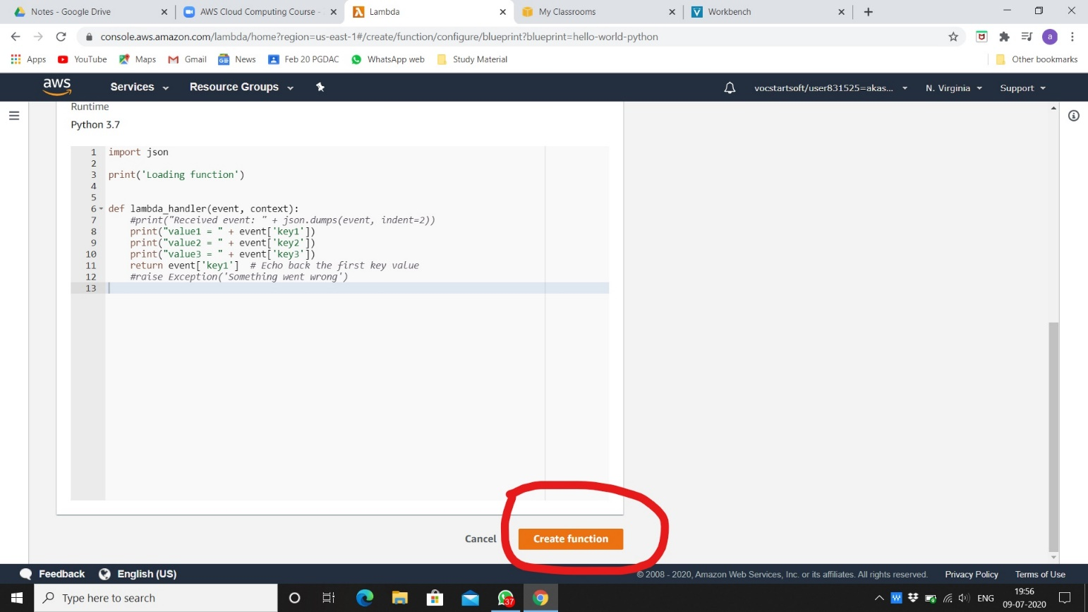

1. Your lambda function is successfully created as shown below.

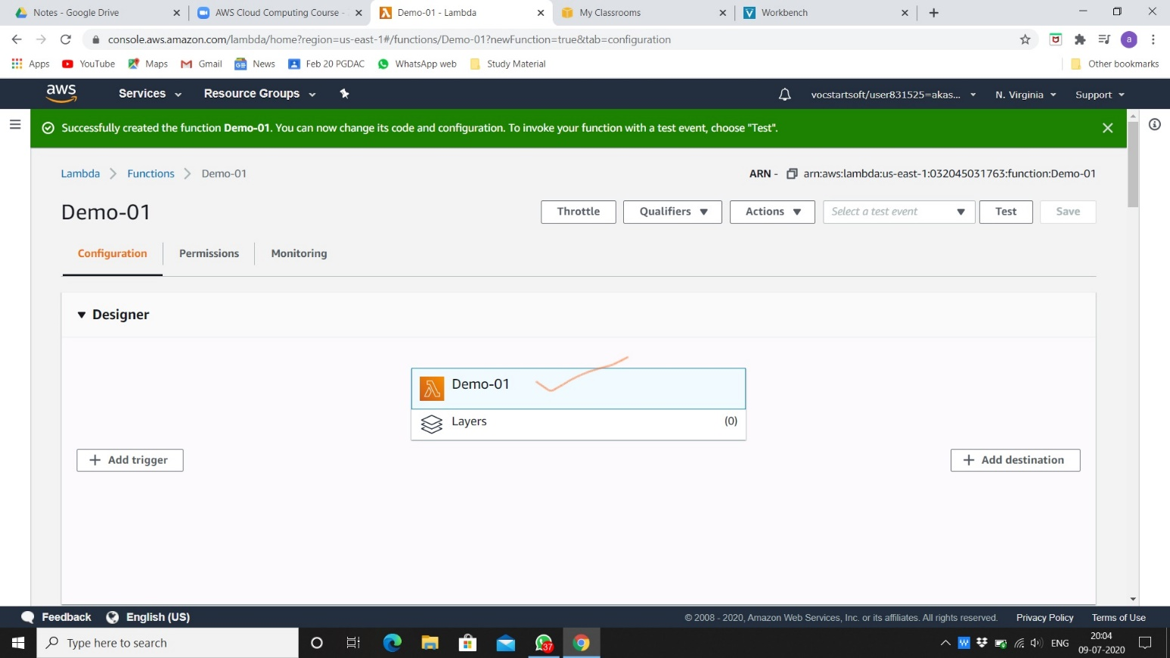

1. Creating new event with key values, you can add anything in that as you want.

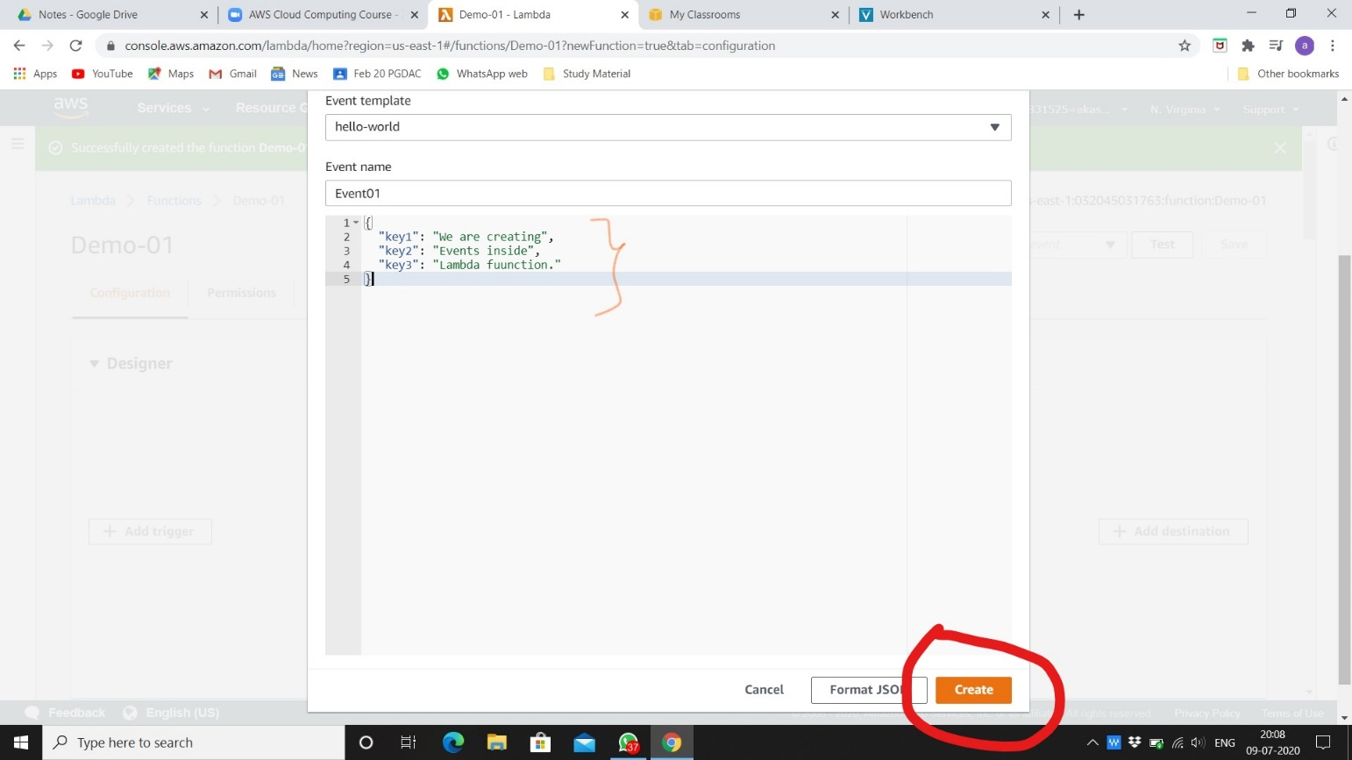

1. After saving and executing event, result showed on log output.

